**AD110: USER INTERFACE DESIGN - Project 1**

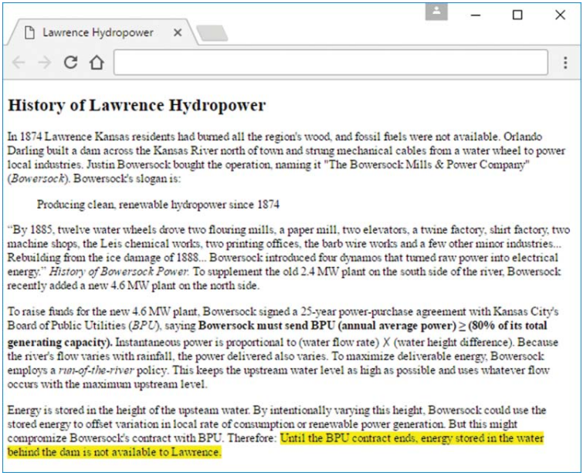

**Program Explanation**

**Project Description:**

Create a web page with a filename of **pgmExplanation.html** that explains something interesting about a program. Your explanation must make sense. You must use grammatically correct sentences that provide a reasonable flow through your web page. Creativity and aesthetics are part of web programming, and they are part of this assignment. Follow these guidelines:

1. Include at least one heading (h1, h2, etc.) in your web page.
2. Display a code fragment from the program, or display the whole program, if appropriate. Feel free to create the program yourself or use a program that you find in a book or on the Internet.
3. Refer to a specific variable in the program, specific input, and specific output.
4. Provide a quote from a book that refers to the program or to a concept illustrated by the program, and provide a citation for the book’s title. Feel free to use a real quote from a real book or make up a fictional quote from a fictional book.
5. Provide an acronym (real or made up) or a definition that somehow relates to the web page’s discussion.
6. Include a total of at least 5 different types of phrasing elements in your web page. You must use appropriate phrasing elements that fit the flow of your web page. You will lose points if any of your elements are inappropriate (e.g., using wbr in a normal-length word). For future projects, you will use CSS for formatting. But for practice purposes, for this project, use only HTML5 elements and not CSS.

Submit your complete summary to **Project 1 in Moodle**.

AdonisJS, an extra hand to Help on you Project.

In order to develop a software, there is a great number of features, definitions and patterns to be set, and build one from scratch might be a challenge. Because of that, many frameworks project raised, which basically any programing language have at least one framework to help build software’s over it, such as, Laravel and WordPress for PHP, Rails for Ruby, Django for Python, and so on.

On the same path, after NodeJS turned possible run JavaScript on the server side, AdonisJS came up to share t

**FOR INSTRUCTOR USE ONLY**

**Grading Rubric**

*Grading accepts a start value of 100. Points will be deducted for failure to fully complete or meet the stated requirements. Grading: 90-100 = Represents work of superior quality (A); 80-89 = Represents work of good to very good quality (B); 70-79 = Represents adequate command of class content (C); 69 and below = Represents work that shows a need for development or improvement (F); 0 = Represents plagiarized work (F).*

**AD110: USER INTERFACE DESIGN (NCP-WEB)**

**Student:**

**Instructor:**

**Date:**

**Project 1**

|  |  |  |
| --- | --- | --- |
| **Description of requirements** | **Possible Points** | **Your Points** |
| 1. Create a web page with a filename of pgmExplanation.html | **15** |  |
| 1. Include at least one heading (h1, h2, etc.) in your web page | **15** |  |
| 1. Display a code fragment from the program, or display the whole program, if appropriate. (Paragraph Block) | **15** |  |
| 1. Provide a quote from a book that refers to the program or to a concept illustrated by the program. (Blockquote) | **15** |  |
| 1. Provide an acronym (real or made up) or a definition that somehow relates to the web page’s discussion. | **15** |  |
| 1. Include a total of at least 5 different types of phrasing elements in your web page. | **25** |  |
| **TOTAL** | **100** |  |

**YOUR SCORE**: ________

**Instructor Comments:**